**KUNJ SHAH**

**FYIT-141**

1

**PRACTICAL 4 TITLE: WIKIPEDIA, ACCOUNT CREATING, CREATING PAGE AND EDITING IT.**

1. **What is Wikipedia?**

Ans. - Wikipedia is a free, open content online encyclopedia created through the collaborative effort of a community of users known as Wikipedians. Anyone registered on the site can create an article for publication; registration is not required to edit articles. The site's name comes from wiki, a server program that enables anyone to edit Web site content through their Web browser.

Jimmy Wales and Larry Sanger co-founded Wikipedia as an offshoot of an earlier encyclopedia project, Nupedia, in January 2001. Originally, Wikipedia was created to provide content for Nupedia. However, as the wiki site became established it soon grew beyond the scope of the earlier project. As of January 2015, the website provided well over five million articles in English and more than that number in all other languages combined. At that same time, Alexa ranked Wikipedia as the seventh-most popular site on the Internet. Wikipedia was the only non-commercial site of the top ten.

Criticisms of Wikipedia include assertions that its openness makes it unreliable and unauthorative. Because articles don't include bylines, authors aren't publicly accountable for what they write. Similarly, because anyone can edit any article, the site's entries are vulnerable to unscrupulous edits. In August 2007, Virgil Griffiths created a site, WikiScanner, where users could track the sources of edits to Wikipedia entries. Griffiths reported that self-serving edits typically involved whitewashing or removal of criticism of a person or organization or, conversely, insertion of negative comments into the entry about a competitor. Wikipedia depends upon the vigilance of editors to find and reverse such changes to content.

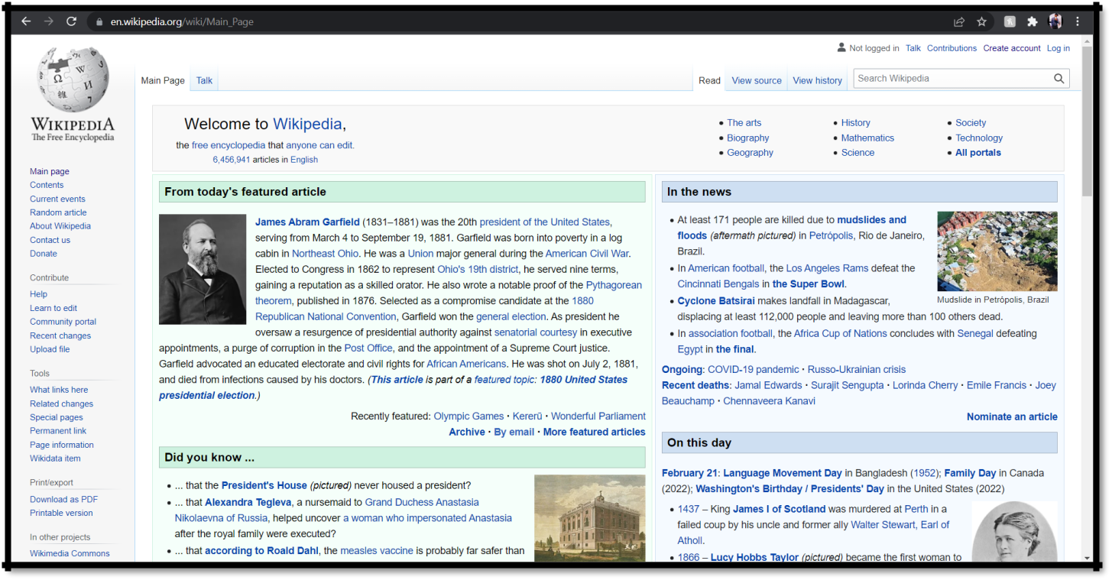

**KUNJ SHAH**

**FYIT-141**

2

1. **Creating an Account.**

Ans- Steps to create Wikipedia account:

* 1. Open a Web browser to Wikipedia.org.
  2. Near the top there will be a Create account button, click on it.
  3. Fill in the details asked in the form.
  4. After your account is created you can see your username at the top ribbon. And you are ready to use your account.

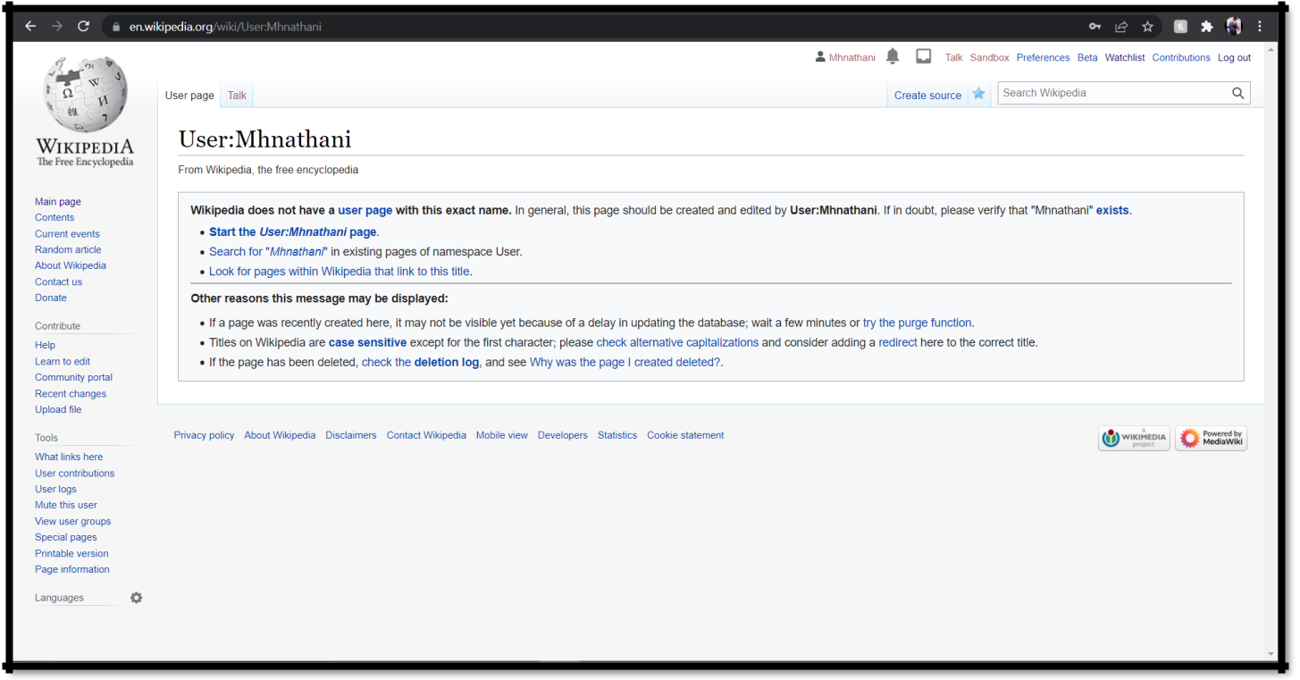

1. **Creating a page on Wikipedia.** Ans-
   1. To start with creating a page remember to Research Your Topic and Gather Resources
   2. Click on the sandbox and create an outline.
   3. Write a draft of your Wikipedia page.
   4. Submit your article for review.
   5. Publish your changes.

**KUNJ SHAH**

**FYIT-141**

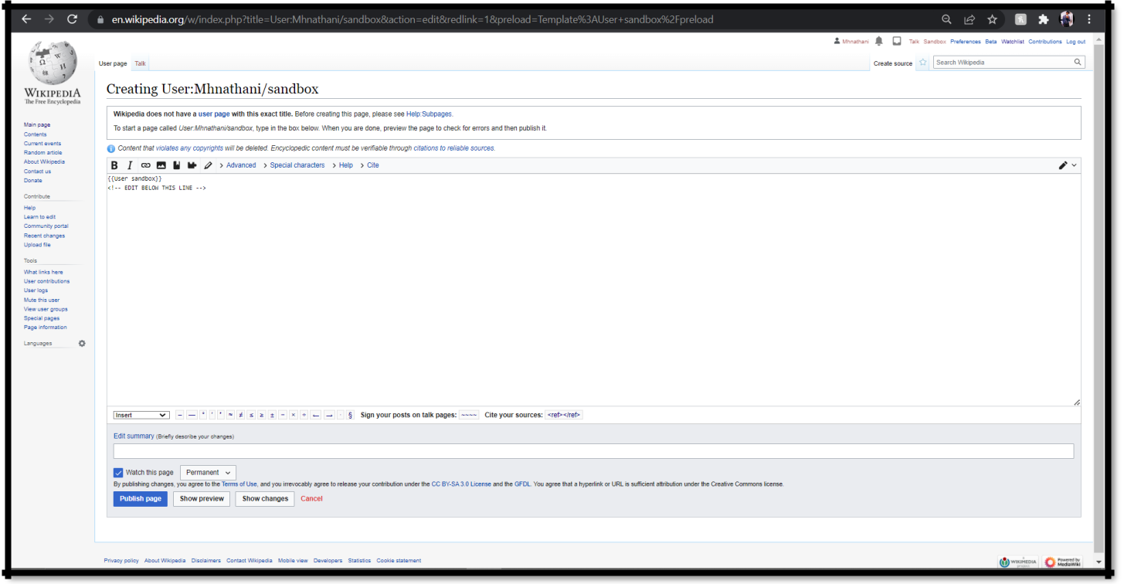

3

1. **Editing Wikipedia document.** Ans-
   1. Select the edit option.
   2. Edit your page.
   3. Publish changes.

